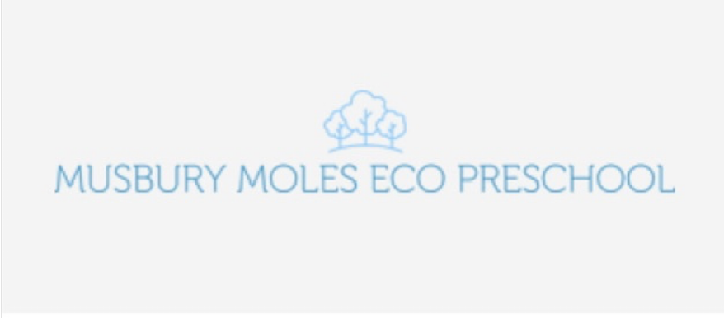

Honour Based Violence and Forced Marriage policy
EYFS: 3.4, 3.6, 3.7
This policy should be read alongside our Safeguarding policy:
- Safeguarding Children Child Protection Policy
- Data Protection and Confidentiality
- GDPR Privacy Notice.
The official definition of domestic abuse is: “any incident or pattern of incidents of controlling, coercive or threatening behaviour, violence or abuse between those aged 16 or over who are or have been intimate partners or family members regardless of gender or sexuality. In practice domestic abuse is the abuse of power and control over one person by another and can take many different forms, including physical, sexual, emotional, verbal and financial abuse.
Domestic abuse can happen to anyone regardless of gender, age, social background, religion, sexuality or ethnicity, and domestic abuse can happen at any stage in a relationship.
We aim to develop staff knowledge of recognising the signs and symptoms of domestic violence. These signs may include:
- Changes in behaviour: for example, becoming very quiet, anxious, frightened, tearful, aggressive, distracted, depressed etc.
- Visible bruising or single, or repeated, injury with unlikely explanations
- Change in the manner of dress: for example, clothes that do not suit the climate which may be used to hide injuries
- Partner or ex-partner stalking employee/parent in or around the workplace; this may include excessive phone calls or messages
- Partner or ex-partner exerting an unusual amount of control or demands over work schedule
- Frequent lateness or absence from work.
We will raise awareness of domestic abuse within our setting by:
- Sharing information with external organisations that can offer support with incidents of domestic violence. The information will be displayed in visible spaces within the setting
- Providing all staff with the telephone number for the free 24 hour National Domestic Violence Helpline ( 0808 2000 247)
- Sharing our domestic abuse policy and Child Protection and Safeguarding policies with all stakeholders.
The Domestic Violence, Crime and Victims Act 2004 extended provisions to help stop domestic abuse. It created a new offence "causing or allowing the death of a child or vulnerable adult". This Act was amended in 2012 (Domestic Violence, Crime and Victims (Amendment) Act 2012) to include 'causing or allowing serious physical harm (equivalent to grievous bodily harm) to a child or vulnerable adult'
If we are concerned that domestic violence is happening within a home and a child is at risk, we will follow our safeguarding policies’ reporting procedures (see Child Protection policy).
Where incidents of domestic violence are shared by an employee or parent/carer, we will respect confidentiality at all times and not share information without their permission. However, we will share this information, without permission, in cases of child protection or where we believe there is an immediate risk of serious harm to the person involved.
Honour based violence
Honour based violence (HBV) can be described as ‘a collection of practices, which are used to control behaviour within families or other social groups to protect perceived cultural and religious beliefs and/or honour’; such as being held against their will, sexual or psychological abuse, threats of violence, assault or forced marriage.
Such violence can occur when perpetrators perceive that a relative has shamed the family and/or community by breaking their honour code. It is a violation of human rights and may be a form of domestic and/or sexual violence. There is no honour or justification for abusing the human rights of others.
We aim to develop staff knowledge of recognising the signs and symptoms of HBV. These signs may include:
- Changes in how they dress or act, they may stop wearing ‘western’ clothing or make-up
- Visible injuries, or repeated injury, with unlikely explanations.
- Signs of depression, anxiety or self-harm
- Frequent absences
- Restrictions on friends or attending events.
We will raise awareness of domestic abuse within our setting by:
- Sharing information with external organisations that can offer support with incidents of HBV. The information will be displayed in visible spaces within the setting
- Sharing our HBV, child protection and safeguarding policies with all stakeholders.
Where incidents of HBV are shared by an employee or parent/carer, we will respect confidentiality at all times and not share information without their permission. However, we will share this information without permission in cases of child protection, or where we believe there is an immediate risk of serious harm to the person involved.
Forced Marriage
A forced marriage is defined as ‘a marriage in which one, or both spouses, do not consent to the marriage but are coerced into it. Duress can include physical, psychological, financial, sexual and emotional pressure. In the cases of some vulnerable adults who lack the capacity to consent, coercion is not required for a marriage to be forced’.
If we suspect or receive information about a forced marriage being planned then we will follow our safeguarding reporting procedures. If the person concerned is under the age of 18 years, then we will report the incident to the children’s social care team.
If we believe a person is in imminent danger of being forced into a marriage we may contact the Police and the Governments Forced Marriage Unit (FMU) on 020 7008 0151.

This policy was adopted by - Musbury Moles Eco Preschool
On - 31/1/2022
Date to be reviewed - 31/1/23
Signed on behalf of the provider

Name and role of signatory

